Drought Climatology in Missouri:

Introduction:

What is drought?
Drought as an overarching term is defined as “a prolonged period of abnormally low rainfall, leading to a shortage of water.” According to the Oxford Languages Dictionary. This, however, is not nuanced enough for our purposes. Instead of using the overarching definition, it is best to define drought in different categories. The National Weather Service Classifies Drought in the following categories.^{[1]}
- Meteorological Drought: Based solely on the amount of rainfall that’s occurred in a region over a given amount of time. The less rainfall, the more severe the drought.
- Hydrological Drought: Based on the impact that meteorological drought has on a water supply. This could be a lake, stream, river, etc.
- Agricultural Drought: Based on the impacts that both meteorological and hydrological drought may have on soil, irrigation, etc.
- Socioeconomic Drought: Based on the impacts of meteorological, hydrological, and agricultural drought on the supply and/or demand of goods that depend on water for production. Fruits, vegetables, grains, meat, etc. The National Weather Service explicitly defines this as: “ when the demand for an economic good exceeds supply as a result of a weather-related deficit in water supply.”
For the purposes of this study, we will be exclusively looking at meteorological drought. For more information on how drought was calculated, and the exact thresholds used for drought classification, go to the “Data and Methodology:” section of this text (pg. _).

Why Understand Drought Climatology in Missouri?
Drought unfortunately is common in the state and happens at all levels from meteorological to socioeconomic. The examination of meteorological drought data can be used to mitigate the impacts of meteorological drought, therefore lessening hydrological, agricultural, and socioeconomic impacts. For example, the seasonality of drought is important for those in agriculture to know, depending on their location, whether or not drought onset is becoming a “new normal” every growing season.

Objectives of this study:
The objective of this study is to produce a thorough drought climatology analysis which can be used by the public and researchers alike to get an understanding of Missouri’s drought characteristics over the past 24 years using Missouri Mesonet data.

Data and Methodology:

Spatial and Temporal Coverage of Analysis:
The drought climatology analysis done for the State of Missouri includes every Missouri mesonet station within the state that passed quality control checks. Analysis was done for the following locations:
- Albany, Gentry County, MO
- Auxvasse, Audrain County, MO
- Brunswick, Carroll County, MO
- Cardwell, Dunklin County, MO
- Charleston, Mississippi County, MO
- Clarkton, Dunklin County, MO
- Columbia-Sanborn Field, Boone County, MO
- Columbia-South Farms, Boone County, MO
- Cook Station, Crawford County, MO
- Corning, Atchison County, MO
- Delta, Cape Girardeau County, MO
- Glennonville, Dunklin County, MO
- Hayward, Pemiscot County, MO
- Lamar, Barton County, MO
- Linneus, Linn County, MO
- Monroe City, Monroe County, MO
- Novelty, Knox County, MO
- Portageville, Pemiscot County, MO
- St. Joseph, Buchanan County, MO
Temporal coverage at every location listed above is from January 1st, 2000 to May 31st, 2024. Raw data was daily and converted to monthly for the purposes of this study.

Data Sources:
Data was almost exclusively obtained from Missouri Mesonet stations.^{[2]} This was done because one of the main objectives of this study is to show the utility of the Missouri Mesonet in serving the public. Other data sources were needed, however, in the scenario that data from a Mesonet station was missing for a small, period of time, as the completeness of the dataset is not a trivial matter. We determined that up to 8 months of data missing was acceptable, if more than that was missing, the mesonet station in question was not used for this analysis. Other sources were NWS COOP stations^{[3]}, within 10 miles of the mesonet station in most cases (exceptions explicitly stated in the Data Quality Control section), and the National Water Prediction Center Precip Estimate (Multi-Sensor Data)^{[4]}.

Data Quality Control:
Data quality control was done by hand, with the assistance of programming. A Python program compiled the following about each data file. File name (Location), the first and last day of data in the file. The highest and lowest precip values during the period, as well as missing days in the file. These outputs were manually looked through and used to ensure that data was the way you’d expect it to be. This was not the case at first but ultimately the data had no faulty readings with missing data, strange values, or start/end dates.

Calculation of SPI (Standard Precipitation Index):
The NOAA SPI generator program was used to calculate SPI values using the data previously mentioned above. It was reformatted via a python program to ensure compatibility with the SPI generator program. This program exported excel files for use in data analysis. The data exported was the 1 month, 3 month, 6 month, and 12 month SPI data, as well as drought periods at -1.0, -1.5, -2.0, -2.5, -3.0, -3.5, and -4.0 thresholds at the previously mentioned time scales. Drought frequency at different time scales was also output with various different thresholds. The calculations from the SPI generator program and the resultant data was used for identifying the trends and visualizations you will see later in the paper.

Drought Data Analysis:

Notes about Data Analysis:
The following data analysis will be done using the SPI data obtained. The following variables will be examined, SPI Intensity, with the threshold values of -0.5 and -1.3 being selected. These SPI values are the two which are most significant since they represent the D0 (abnormally dry) and D2 (severe) drought categories respectively.^{[5]} In other words, you can look at -0.5 as the onset of low impact drought, and -1.3 as the onset of high impact drought. Using these two thresholds as our primary values for analysis, additional variables nested within these were also examined, such as drought frequency, and spaciotemporal patterns, such as duration and seasonality. These were also look at for 3 of the 4 time scales in the analysis, that being 03M, 06M, and 12M. These time scales were particularly useful as they represented a few different and quite important time scales.
3-month SPI represents seasonal drought, as it allows you to see what the past season’s worth of rainfall has been. This is reflective of short-medium term trends in drought, and while not super reactive to one-month variance, it is reactive enough to reflect seasonal changes in precipitation, however for some areas it maybe too reactive to reflect the medium-long term changes in drought that occur at a given location.
That’s where 6-month SPI comes in. 6-month SPI is great for monitoring medium-term trends, and is fantastic for seeing the overall seasonal rainfall of a given location, as it can capture what the conditions were heading into a season, rather than that season alone in a vacuum. For some though, especially those who care about the long-term, this time scale can still be a bit too reactive.
That’s why 12-month SPI exists. It accounts for the previous year’s precipitation and draws conclusions from that. So while 3-month SPI may react to one good month of precipitation, the 12-month SPI won’t be so reactive. Longer SPI’s tend to be less extreme than their short-term counterparts unless there is a short-term change in trend that is not yet reflected in the long-term.^{[6]}
Drought frequency and duration, what’s the difference? For the purposes of this paper, there is drought frequency, average duration, and cumulative duration. Drought frequency describes the amount of months a that a certain drought condition is present. Average duration takes the length of each drought event (drought end – drought start), and takes its mean. Cumulative drought duration adds the duration of each drought event (drought end – drought start) and gives the sum. You would think that the drought frequency and cumulative duration outputs would be the same, however this is not the case because (and it turns out, this was the beginning of a painful… painful journey)

Short-Term Drought:
Short-term drought for the purposes of this article will be drought that can be classified using 3-month worth of precipitation data, which is in other words the 03M SPI. This drought best captures seasonal and sub-seasonal changes in precipitation, which can tell us a lot about where seasonal drought is most common, what seasons tend to be most prone to drought, and how long the drought may last.

Duration:

Average Duration:
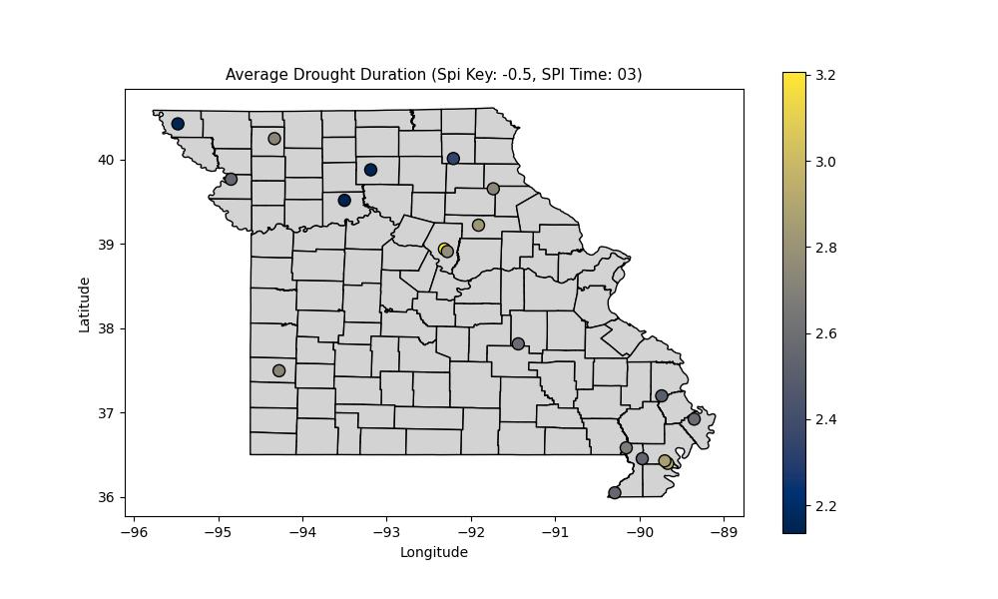
Average drought duration across Missouri for low-intensity drought is pretty similar for a vast majority of stations, there is an outlier of Boone Counties Sanborn field station which has an average low-impact drought duration of over 3 months! This is not a trivial difference, and there are a few possible reasons for this from station placement, to microclimatological factors. Subjectively the Mizzou Meteorology program has witnessed precip on many occasions and seen Sanborne not report it. This is normally in low precip events, but that 0.01-0.05” could make a big enough difference to influence the duration of drought. This may need to be investigated further in a future study. Beyond this, though, it is clear that average drought duration across the state is fairly similar at 2-3 months. Droughts seem to on average be a little shorter in the northern portion of Missouri than the southern portion.
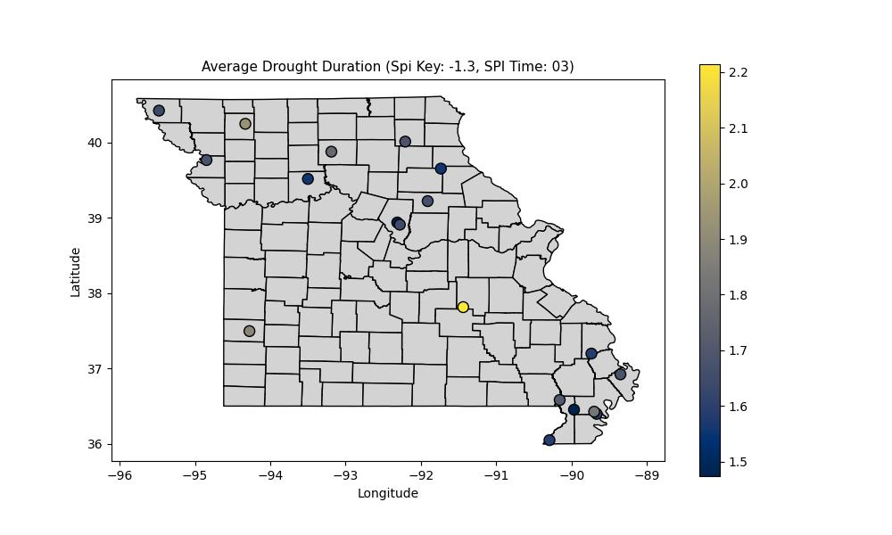
High impact drought duration sheds light on another outlier station, this time being the Crawford county station. This station has an average high-impact drought duration of 2.2 months, which is going to need further investigation as the rest of the stations are in the 1.5-2 month category. Beyond the outlier it seems like the NW portion of the state has slightly longer average D2 drought durations than other portions of the state.

Cumulative Duration:
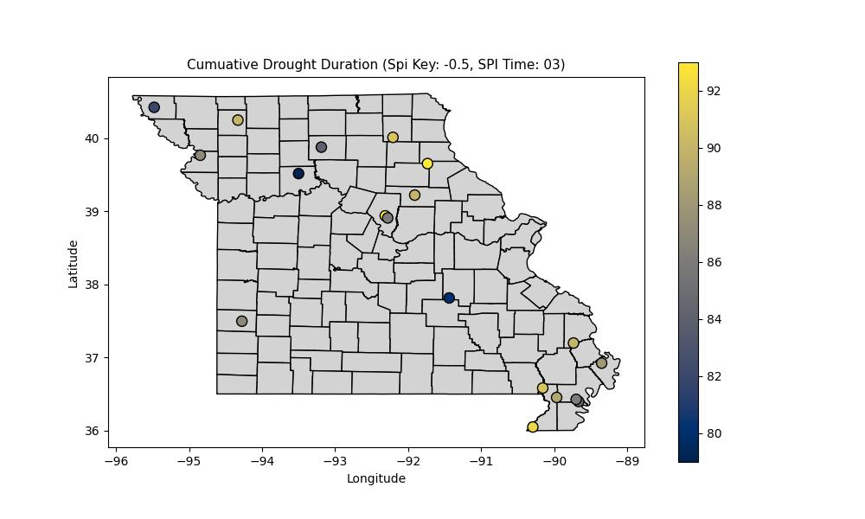
Low-impact drought has occurred somewhat often in the
Will continue this analysis after correcting some potential misinterpretations in the frequency section. (This was also a prompt for the start of a painful journey)

Given the notable spatial discontinuity in the bootheel between the Mississippi county station, and the remaining stations in the boot heel, it seemed prudent that this be investigated further to see where individual drought events may have lasted longer in Mississippi county than at other stations. The most notable period where drought is significantly longer in Mississippi county than any other station in the bootheel is in mid-2004.

One-month SPI, which is a proxy for one-month precip tells us the story, with a large difference between the Mississippi county station and the stations surrounding it in June 2004. So then the question becomes, what happened in June of 2004? What caused such a big difference in precip? The first day with major differences looks to be June 3rd, 2004, where many stations got well over an inch of rain, and Mississippi county only ended up with half an inch or so. There are a few other days like this too.
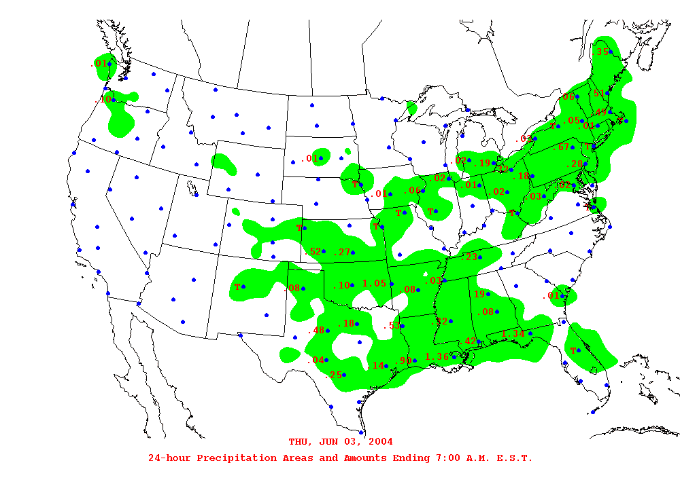
The Weather Prediction Center’s precipitation estimates show this.
June 6th, 2004, many stations get rain, Mississippi county is not part of that
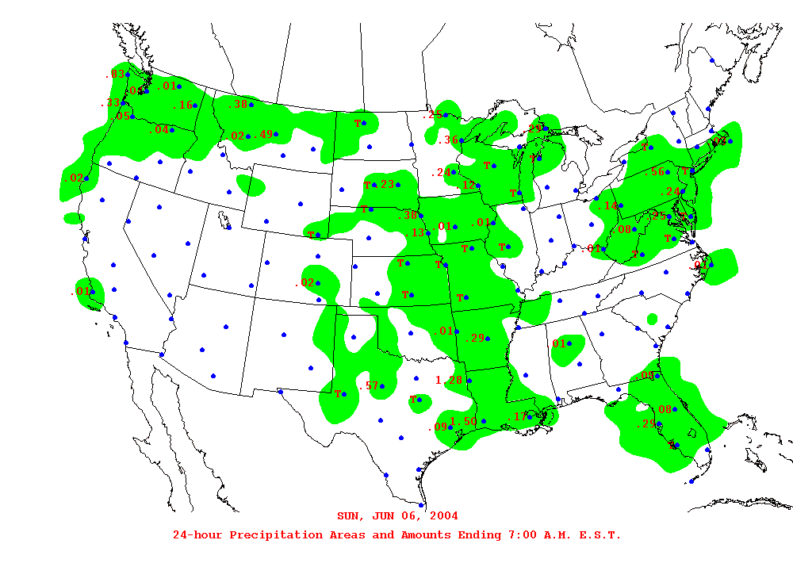
While graphically not depicted super well by WPC archives, June 24th-25th was another stretch where many stations in the bootheel got substantial precip, and Mississippi county got left out again! In other words, there were three big precipitation events that occurred in the bootheel and Mississippi county was missed not one, not two, but three times! This lead to significantly lower precip than any other station in the bootheel, because while some stations missed one or two of the events, Mississippi county is the only station to have missed all three.

Spatial Variability in short-term precip in the Bootheel:
After further investigation it turns out there are quite a few instances of the Missouri bootheel having an outlier station in a given month. This happens given the small scale nature of heavy precip events sometimes, but what makes this interesting is that in all but one case that’s been found, the discontinuity is in Mississippi county. While usually Mississippi counties station reports far less precip in most of these months, there is an instance where the discontinuity is because the station got significantly more precipitation than the other stations. 07/2015 is the only one of these discontinuities where the Mississippi county station isn’t the outlier, instead, it’s a New Madrid county station. Delving into each of these specific events would be worthy of a standalone paper, so a somewhat coarse and rudimentary analysis is all that’s to be done for now.
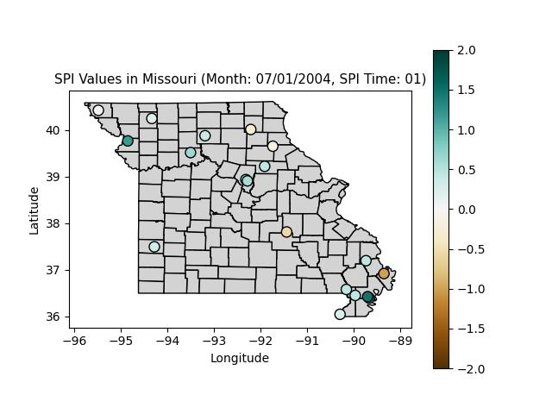
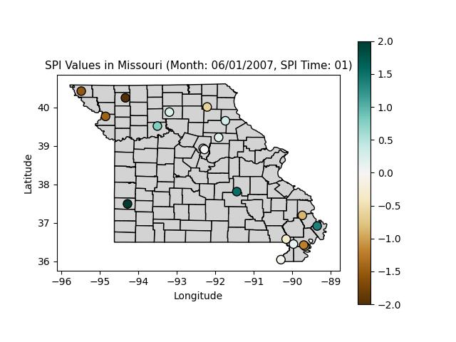
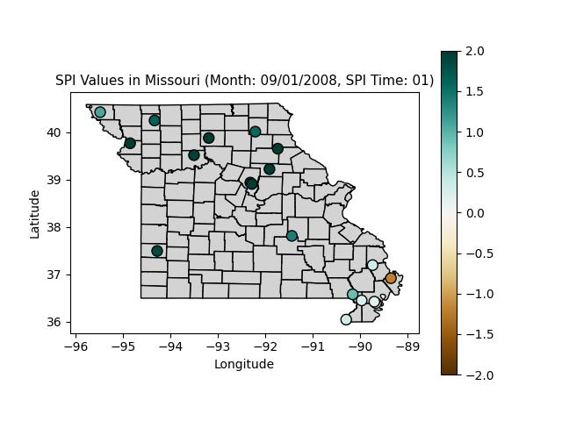
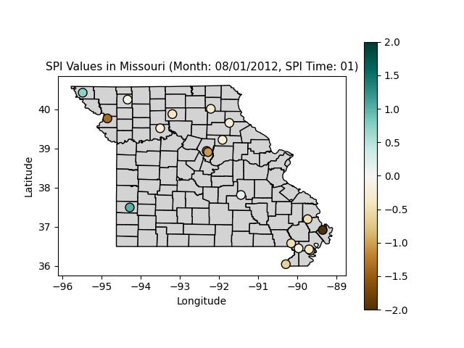
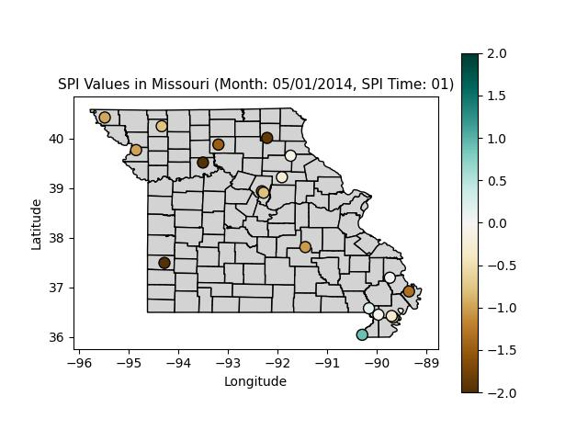
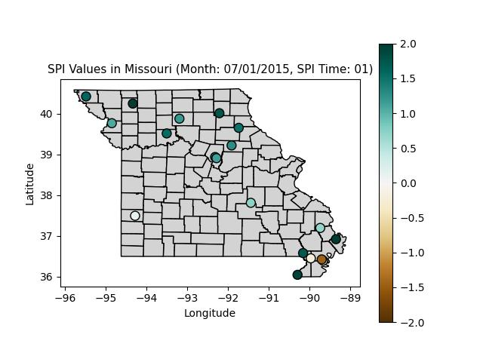
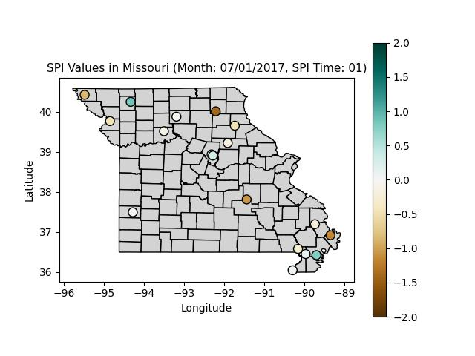

Longest Duration:
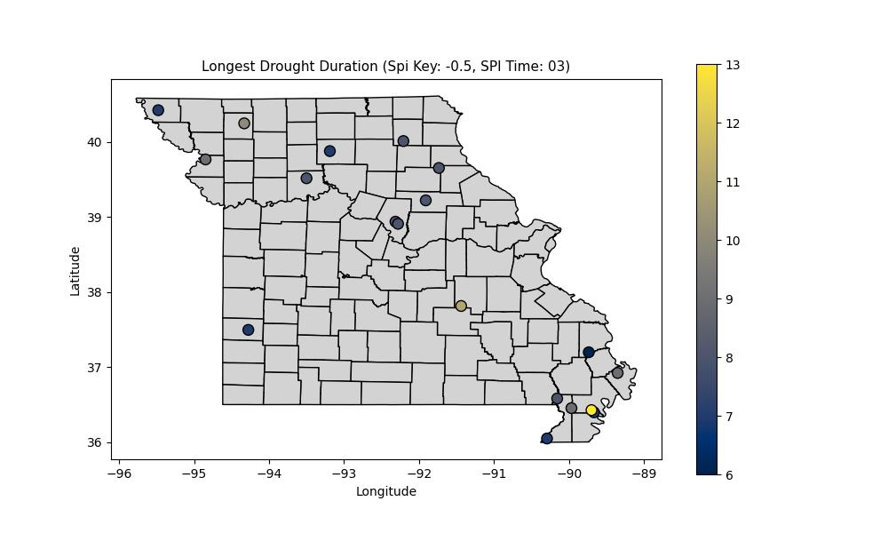
The longest duration low-impact drought in the state goes to the Portageville, Pemiscot County, MO station, with 13 months of seasonal drought, which is quite a long time. Strangely (or not at this point), there is more spacial discontinuity in the bootheel, with all of the stations close to the Portageville one reporting substantially shorter longest durations, and who knows, they may not even be from the same time period! The shortest longest drought (what a way to phrase that, not the least bit confusing), is 6 months at the Delta, Cape Girardeau County, MO station. It also looks like NW MO has had a slightly longer drought than those in C-NE MO.
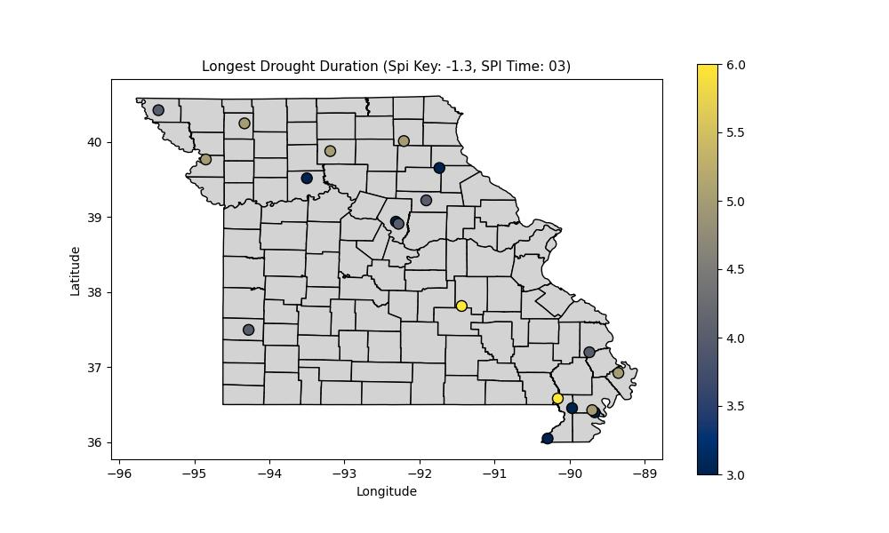
The longest high-impact drought is a two way tie between the Cook Station, Crawford County, MO station and the Glennonville, Dunklin County, MO station. There has been a trend of low drought being reflected in the east, and high drought reflected in the west, when it comes to the longest droughts experienced by different portions of the state this is reversed a little bit, especially in SE MO.

Conclusions:

Key Findings:

Implications for Policy Makers and Stakeholders:

For Future Research:

